ABC’s Inventory Management System

Manage Product (Add Product) Test Scripts

Table of Contents

APT001- Enter all details accurately to add a new product 3

Data Set 1 4

Result Screenshots: 4

APT002- Enter all details accurately but skip some fields while adding a new product 6

Data Set 1 7

Result Screenshots: 7

Data Set 2 9

Result Screenshots: 9

APT003- Enter all details accurately but enter a product code that already exists. 12

Data Set 1 12

Result Screenshots: 12

APT004- Enter an invalid product code 15

Data Set 1 15

Result Screenshots: 15

Data Set 2 17

Result Screenshots: 18

APT005- Enter an invalid price 20

Data Set 1 20

Result Screenshots: 20

Data Set 2 23

Result Screenshots: 23

APT006- Enter all details then click on the ‘Clear’ Icon 25

Data Set 1 26

Result Screenshots: 26

# APT001- Enter all details accurately to add a new product

|  |  |  |  |  |  |
| --- | --- | --- | --- | --- | --- |
| **Test Name** | | Test enter all details accurately to add a new product (Test APT001) | | | |
| **Use Case Tested** | | Manage Product | | | |
| **Test Description** | | This test tests if the system can add a new product by entering all required data accurately. | | | |
| **Pre-Conditions** | | Users need be logged in as a Warehouse Staff (Warehouse Staff Access) in the Manage Product page  Meta data to store Product details in the database must exist. | | | |
| **Post-Conditions** | | A new Product is added to the system. | | | |
| **Result (Pass/Fail/Warning/ Incomplete)** | | Pass | | | |
|  | **Test Step** | | **Expected Test Results** | **P** | **F** |
| 1. | Click on ‘Add Product’ icon at ‘Manage Product’. | | System prompts user to enter new product details. | P |  |
| 2. | Enter all required data accurately. | | System waits for user to click on the ‘Add Product (Tick)’ icon. | P |  |
| 3. | Click on ‘Add Product’ icon. | | The system adds the product details to the database, displays an appropriate message and displays the ‘Add Product Item’ Page for the newly added product. | P |  |

## Data Set 1

|  |  |
| --- | --- |
| **Data Set 1** | |
| **Fields** | **Values** |
| **Product Code** | L1 |
| **Product Name** | Test T-shirt |
| **Price** | 49.00 |
| **Description** | Test T-shirt |

### Result Screenshots:

**Step 1**

After clicking on ‘Add Product’ Icon at ‘Manage Product’ system prompts user to enter new product details

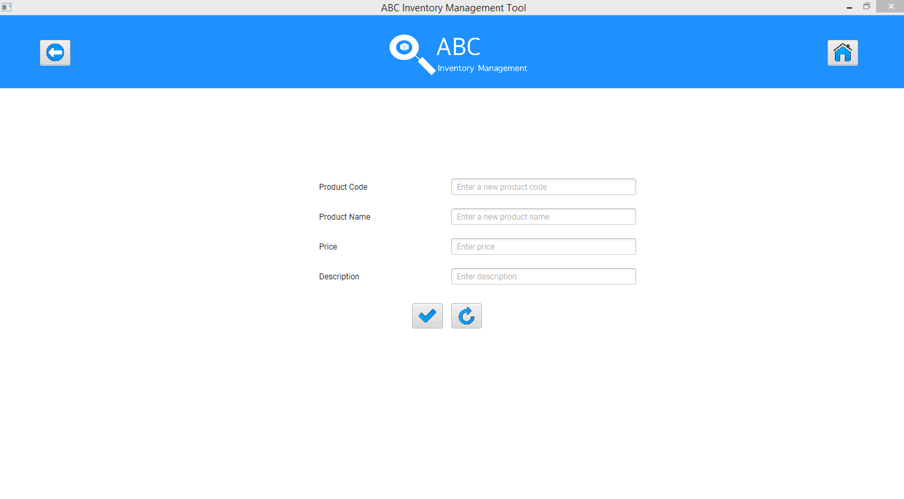

**Step 2**

User enters all required data.

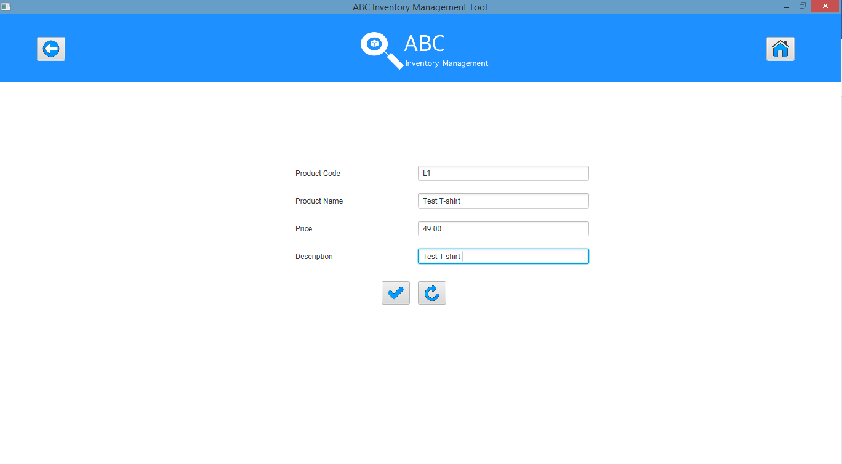

**Step 3**

System displays an appropriate message

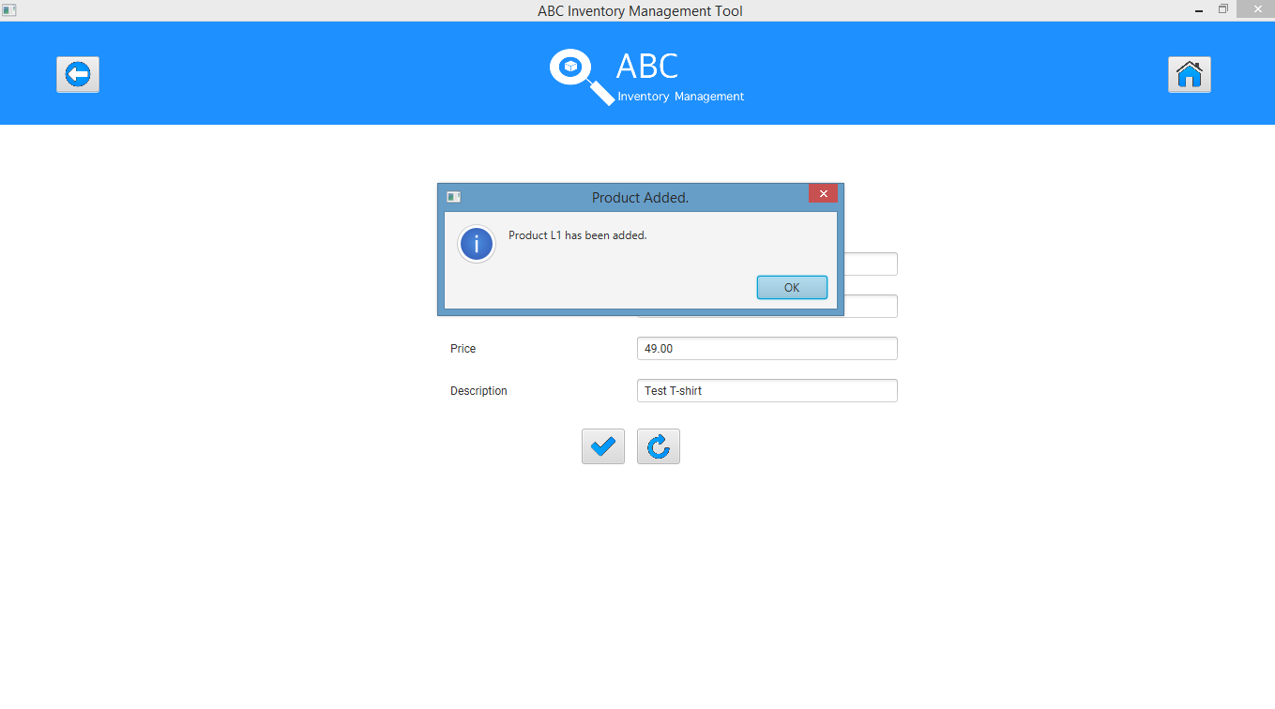

System displays ‘Add Product Item’ page and prompts user to add product items to a location.

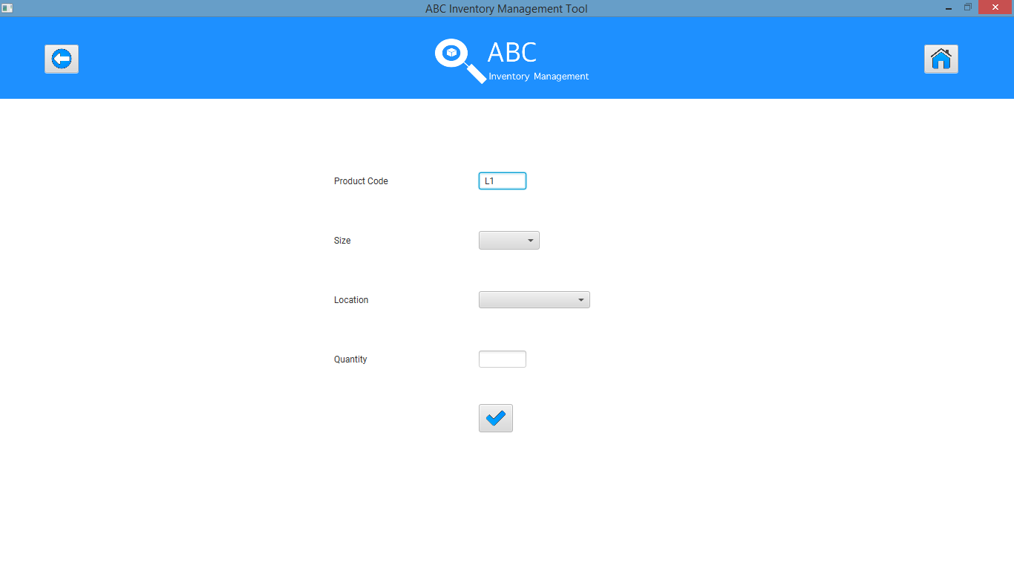

# APT002- Enter all details accurately but skip some fields while adding a new product

|  |  |  |  |  |  |
| --- | --- | --- | --- | --- | --- |
| **Test Name** | | Test enter all details accurately but skip some fields while adding a new product (Test APT002) | | | |
| **Use Case Tested** | | Manage Product | | | |
| **Test Description** | | This test tests how the system reacts when the user does not enter a few details while adding a new Product. | | | |
| **Pre-Conditions** | | Users need be logged in as a Warehouse Staff (Warehouse Staff Access) in the Manage Product page  Meta data to store Product details in the database must exist. | | | |
| **Post-Conditions** | | An appropriate message is displayed.  Details that need to be entered is highlighted. | | | |
| **Result (Pass/Fail/Warning/ Incomplete)** | | Pass | | | |
|  | **Test Step** | | **Expected Test Results** | **P** | **F** |
| 1. | Click on ‘Add Product’ icon at ‘Manage Product’ | | System prompts user to enter new product details. | P |  |
| 2. | Enter all required data accurately but skip price in data set 1 and skip description in data set 2 | | System displays an appropriate message. | P |  |
| 3. | Click on ‘Ok’ button. | | The system highlights the fields that need to be entered. | P |  |

## Data Set 1

|  |  |
| --- | --- |
| **Data Set 1** | |
| **Fields** | **Values** |
| **Product Code** | L2 |
| **Product Name** | Test Pant |
| **Price** |  |
| **Description** | Test Pant |

### Result Screenshots:

**Step 1**

After clicking on ‘Add Product’ Icon at ‘Manage Product’ system prompts user to enter new product details



**Step 2**

Enter all data accurately except for Price.

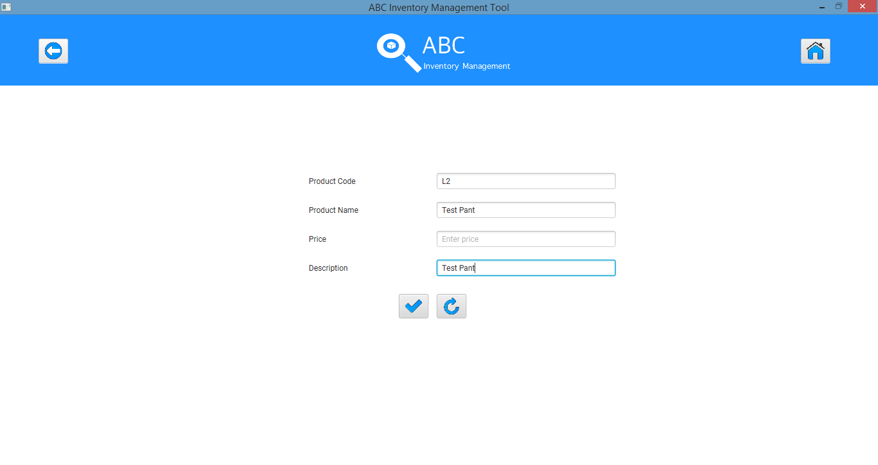

**Step 3**

System displays an appropriate message and the user clicks on Ok.

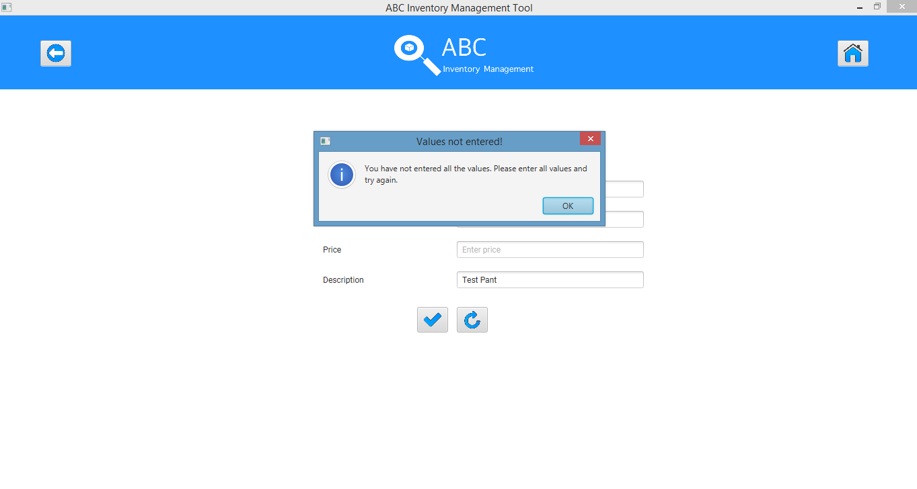

**Step 4**

System highlights Price field so that the user knows it needs to be filled.

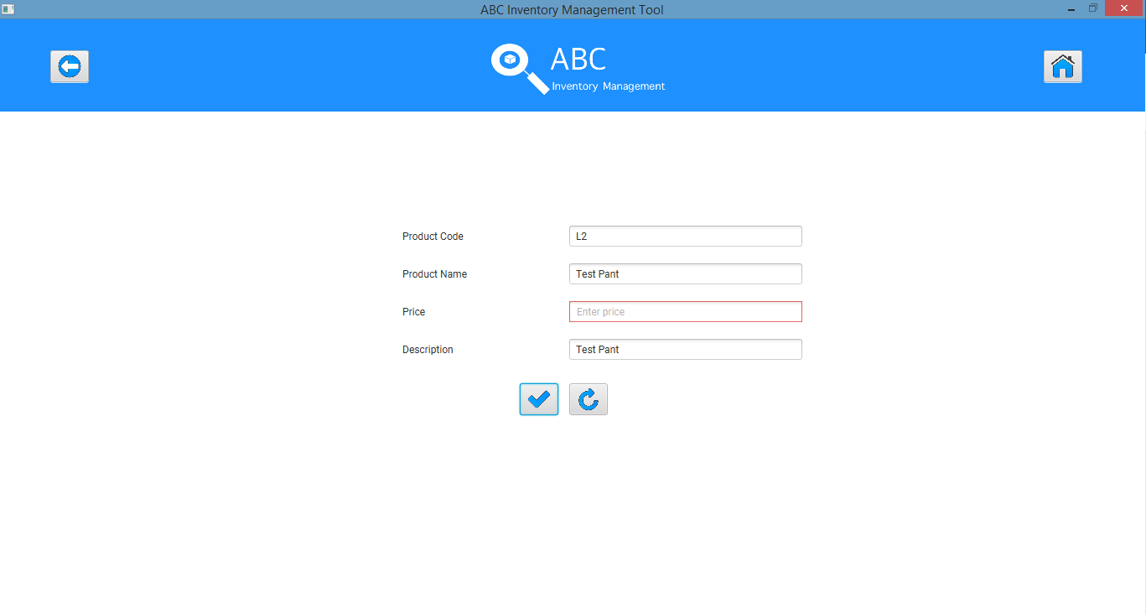

## Data Set 2

|  |  |
| --- | --- |
| **Data Set 2** | |
| **Fields** | **Values** |
| **Product Code** | L2 |
| **Product Name** | Test Pant |
| **Price** | 99.00 |
| **Description** |  |

### Result Screenshots:

**Step 1**

After clicking on ‘Add Product’ Icon at ‘Manage Product’ system prompts user to enter new product details



**Step 2**

Enter all data accurately except for Description.

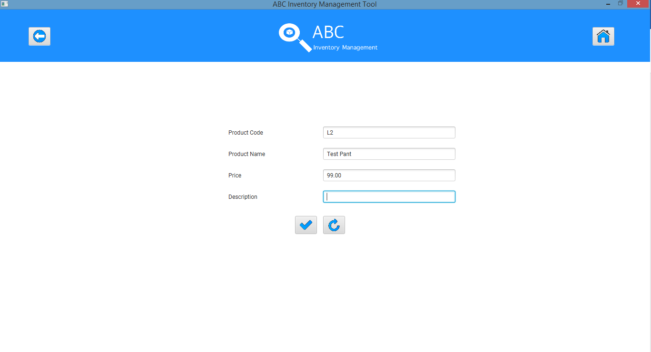

**Step 3**

System displays an appropriate message and the user clicks on Ok.

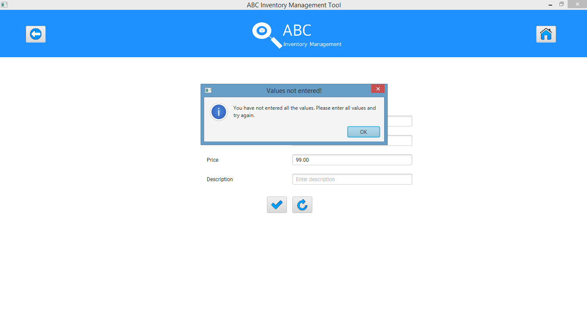

**Step 4**

System highlights Description field so that the user knows it needs to be filled.

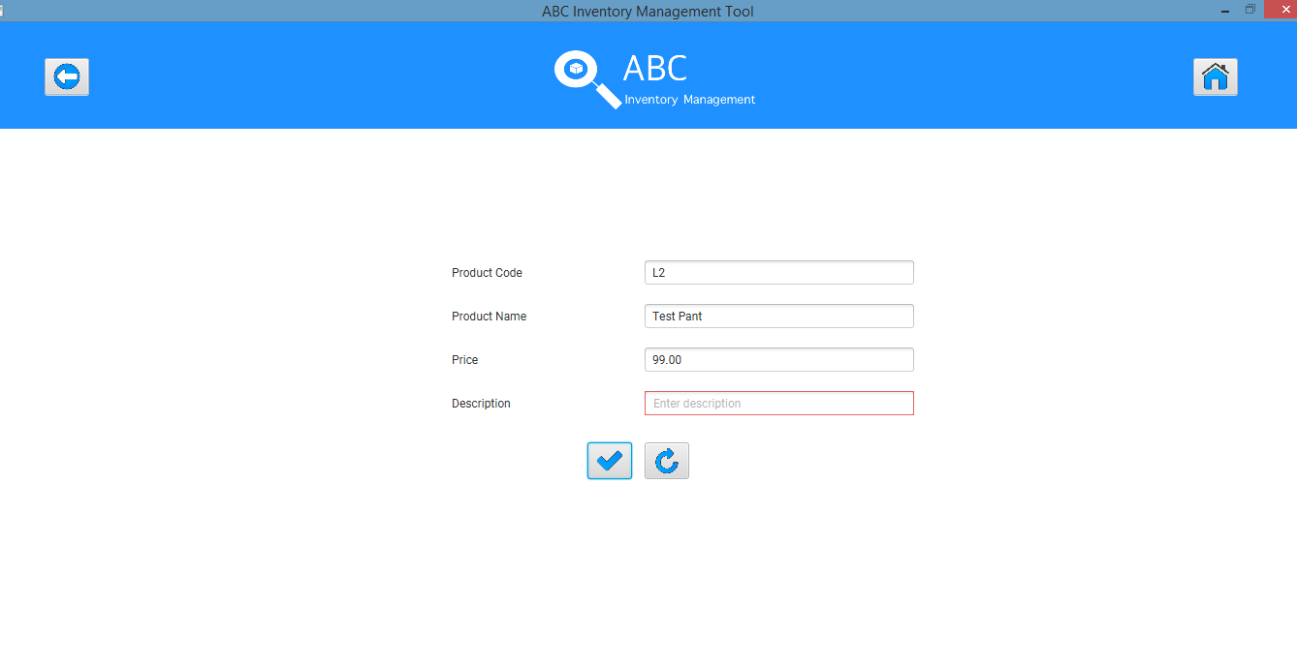

# APT003- Enter all details accurately but enter a product code that already exists.

|  |  |  |  |  |  |
| --- | --- | --- | --- | --- | --- |
| **Test Name** | | Test enter all details accurately but enter a product code that already exists. (Test APT003) | | | |
| **Use Case Tested** | | Manage Product | | | |
| **Test Description** | | This test tests how the system reacts when the user enters all details accurately but enters a product code that already exists. | | | |
| **Pre-Conditions** | | Users need be logged in as a Warehouse Staff (Warehouse Staff Access) in the Manage Product page  Meta data to store Product details in the database must exist. | | | |
| **Post-Conditions** | | An appropriate message is displayed, and the system prompts user to add products to a Location for the product code entered. | | | |
| **Result (Pass/Fail/Warning/ Incomplete)** | | Pass | | | |
|  | **Test Step** | | **Expected Test Results** | **P** | **F** |
| 1. | Click on ‘Add Product’ icon at ‘Manage Product’. | | System prompts user to enter new product details. | P |  |
| 2. | Enter all required data accurately but enter a product code that already exists. | | System waits for user to click on the ‘Add Product (Tick)’ icon. | P |  |
| 3. | Click on ‘Add Product’ icon. | | The system displays an appropriate message. | P |  |
| 4. | Click on ‘Ok’ | | The system prompts user to add products of a particular size to a Location for the product code entered. |  |  |

## Data Set 1

|  |  |
| --- | --- |
| **Data Set 1** | |
| **Fields** | **Values** |
| **Product Code** | L1 |
| **Product Name** | TEST |
| **Price** | 49.00 |
| **Description** | TEST |

### Result Screenshots:

**Step 1**

After clicking on ‘Add Product’ Icon at ‘Manage Product’ system prompts user to enter new product details



**Step 2**

Enter all details accurately but enter a product code that already exists.

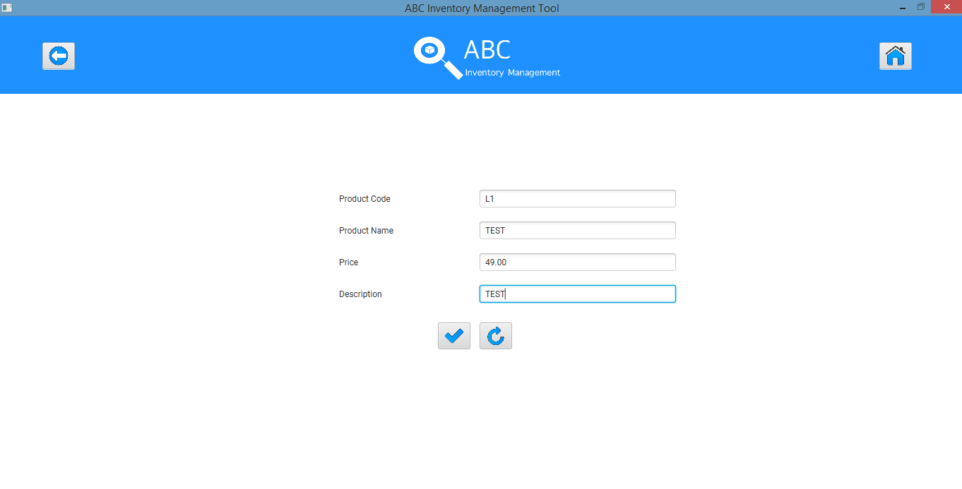

**Step 3**

System displays an appropriate message.

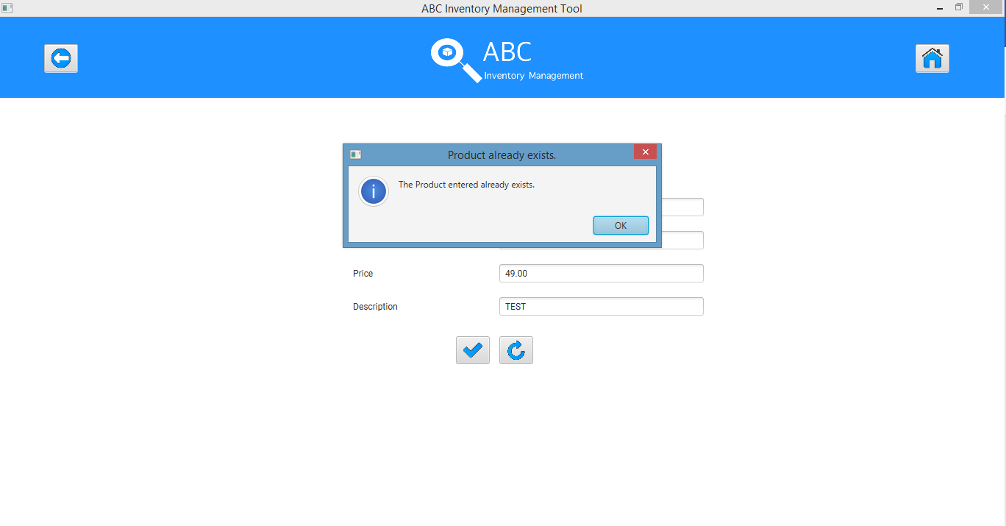

**Step 4**

After the user to clicks on ‘Ok’ the system prompts user to add products of a particular size to a Location for the product code entered.

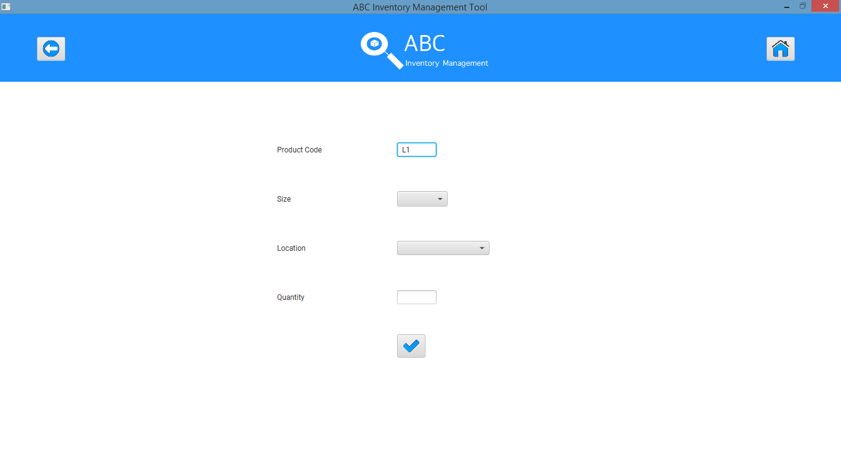

# APT004- Enter an invalid product code

|  |  |  |  |  |  |
| --- | --- | --- | --- | --- | --- |
| **Test Name** | | Test enter an invalid product code. (Test APT004) | | | |
| **Use Case Tested** | | Manage Product | | | |
| **Test Description** | | This test tests how the system reacts when the user enters an invalid product code | | | |
| **Pre-Conditions** | | Users need be logged in as a Warehouse Staff (Warehouse Staff Access) in the Manage Product page  Meta data to store Product details in the database must exist. | | | |
| **Post-Conditions** | | An appropriate message is displayed, and the system prompts user to enter a valid product code. | | | |
| **Result (Pass/Fail/Warning/ Incomplete)** | | Pass | | | |
|  | **Test Step** | | **Expected Test Results** | **P** | **F** |
| 1. | Click on ‘Add Product’ icon at ‘Manage Product’. | | System prompts user to enter new product details. | P |  |
| 2. | Enter all required data accurately but enter an invalid product code (Code that does not have the format of an alphabet followed by a numeral (For example- A1). | | System waits for user to click on the ‘Add Product (Tick)’ icon. | P |  |
| 3. | Click on ‘Add Product’ icon. | | The system displays an appropriate message and prompts the user to enter a valid product code. | P |  |
| 4. | Click on ‘Ok’ | | The system clears the product code field and highlights it in red. |  |  |

## Data Set 1

|  |  |
| --- | --- |
| **Data Set 1** | |
| **Fields** | **Values** |
| **Product Code** | A10 |
| **Product Name** | TEST |
| **Price** | 49.00 |
| **Description** | TEST |

### Result Screenshots:

**Step 1**

After clicking on ‘Add Product’ Icon at ‘Manage Product’ system prompts user to enter new product details



**Step 2**

Enter an invalid product code.

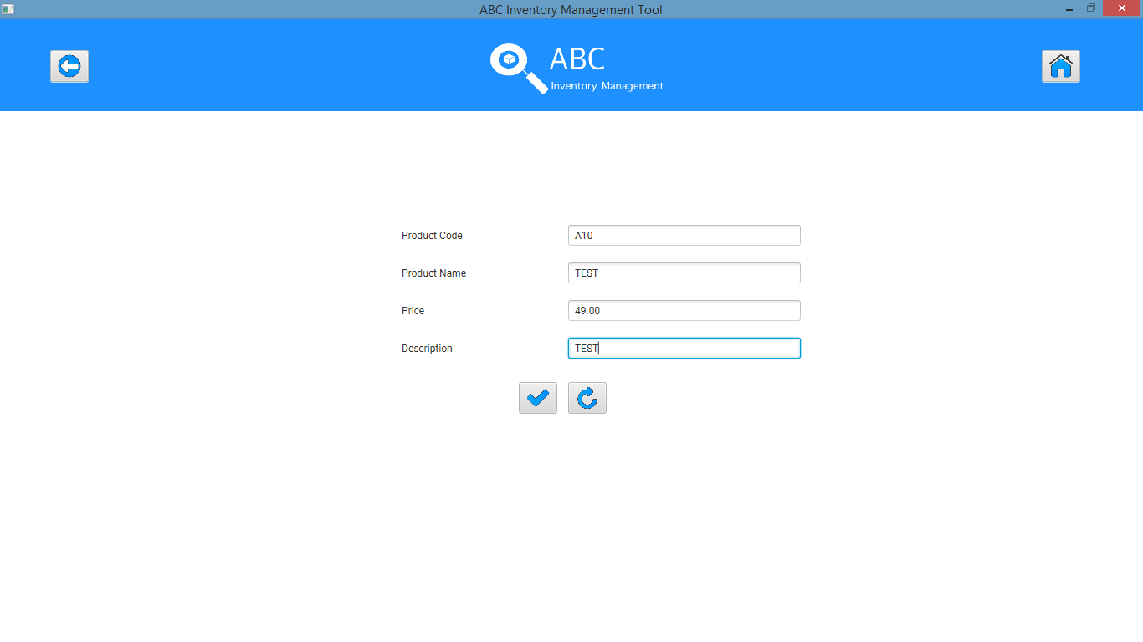

**Step 3**

System displays an appropriate message

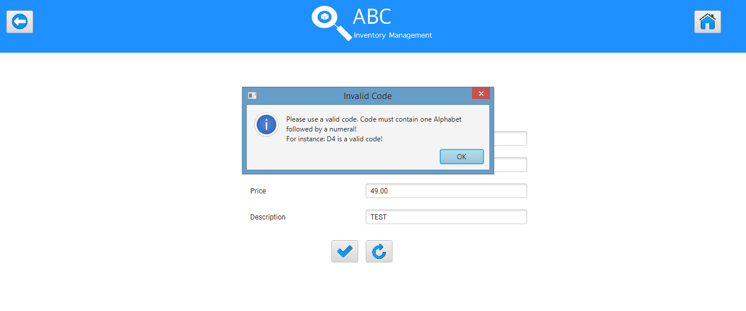

**Step 4**

System clears the product code field and highlights it with red.

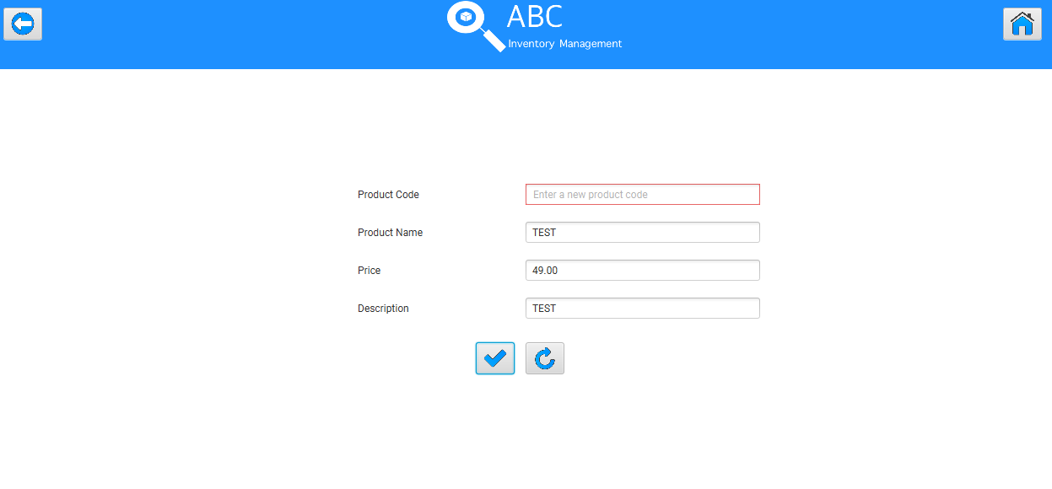

## Data Set 2

|  |  |
| --- | --- |
| **Data Set 2** | |
| **Fields** | **Values** |
| **Product Code** | gyy |
| **Product Name** | TEST |
| **Price** | 49.00 |
| **Description** | TEST |

### Result Screenshots:

**Step 1**

After clicking on ‘Add Product’ Icon at ‘Manage Product’ system prompts user to enter new product details



**Step 2**

Enter an invalid product code.

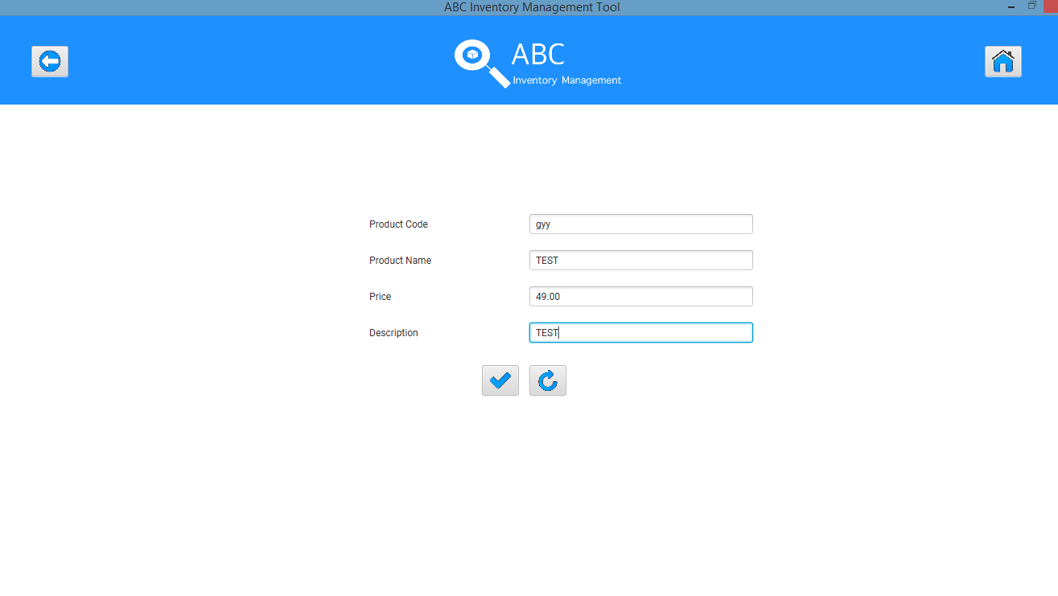

**Step 3**

System displays an appropriate message

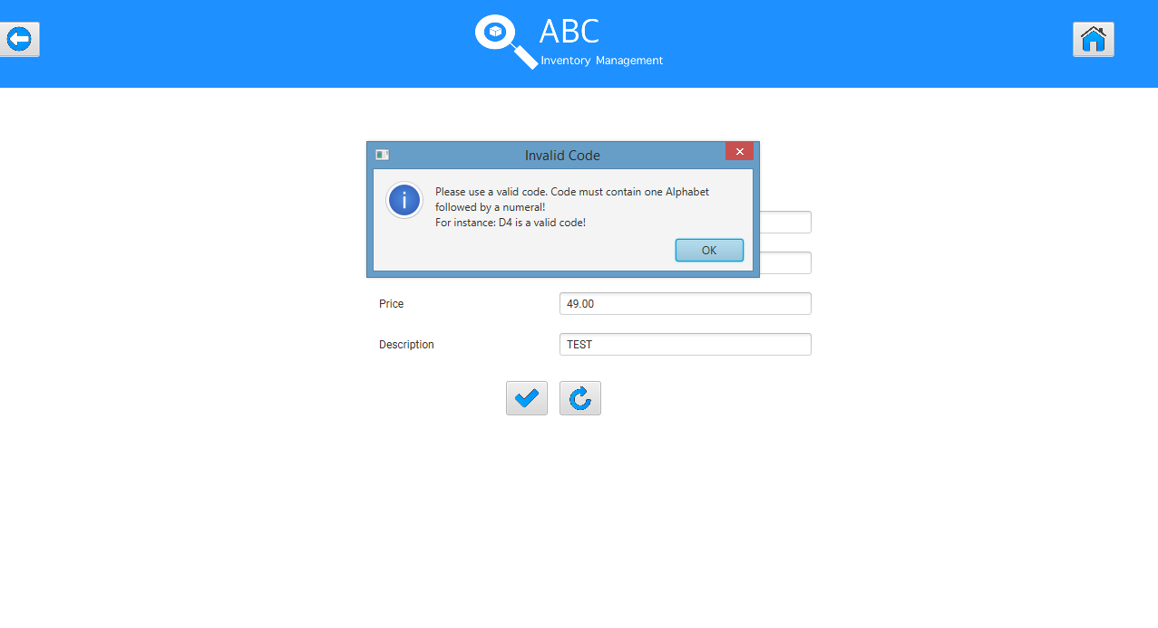

**Step 4**

System clears the product code field and highlights it with red.

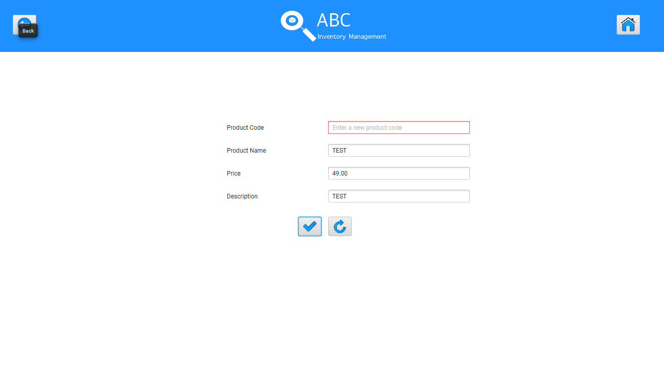

# APT005- Enter an invalid price

|  |  |  |  |  |  |
| --- | --- | --- | --- | --- | --- |
| **Test Name** | | Test enter an invalid price. (Test APT005) | | | |
| **Use Case Tested** | | Manage Product | | | |
| **Test Description** | | This test tests how the system reacts when the user enters an invalid price | | | |
| **Pre-Conditions** | | Users need be logged in as a Warehouse Staff (Warehouse Staff Access) in the Manage Product page.  Meta data to store Product details in the database must exist. | | | |
| **Post-Conditions** | | An appropriate message is displayed, and the system prompts user to enter a valid price value. | | | |
| **Result (Pass/Fail/Warning/ Incomplete)** | | Pass | | | |
|  | **Test Step** | | **Expected Test Results** | **P** | **F** |
| 1. | Click on ‘Add Product’ icon at ‘Manage Product’. | | System prompts user to enter new product details. | P |  |
| 2. | Enter all required data accurately but enter an invalid price. (Non-numeral price or negative price) | | System waits for user to click on the ‘Add Product (Tick)’ icon. | P |  |
| 3. | Click on ‘Add Product’ icon. | | The system displays an appropriate message and prompts the user to enter a valid price. | P |  |
| 4. | Click on ‘Ok’ | | The system clears the price field and highlights it in red. |  |  |

## Data Set 1

|  |  |
| --- | --- |
| **Data Set 1** | |
| **Fields** | **Values** |
| **Product Code** | L2 |
| **Product Name** | TEST |
| **Price** | abc |
| **Description** | TEST |

### Result Screenshots:

**Step 1**

After clicking on ‘Add Product’ Icon at ‘Manage Product’ system prompts user to enter new product details.



**Step 2**

Enter an invalid price (A non-numeral value).

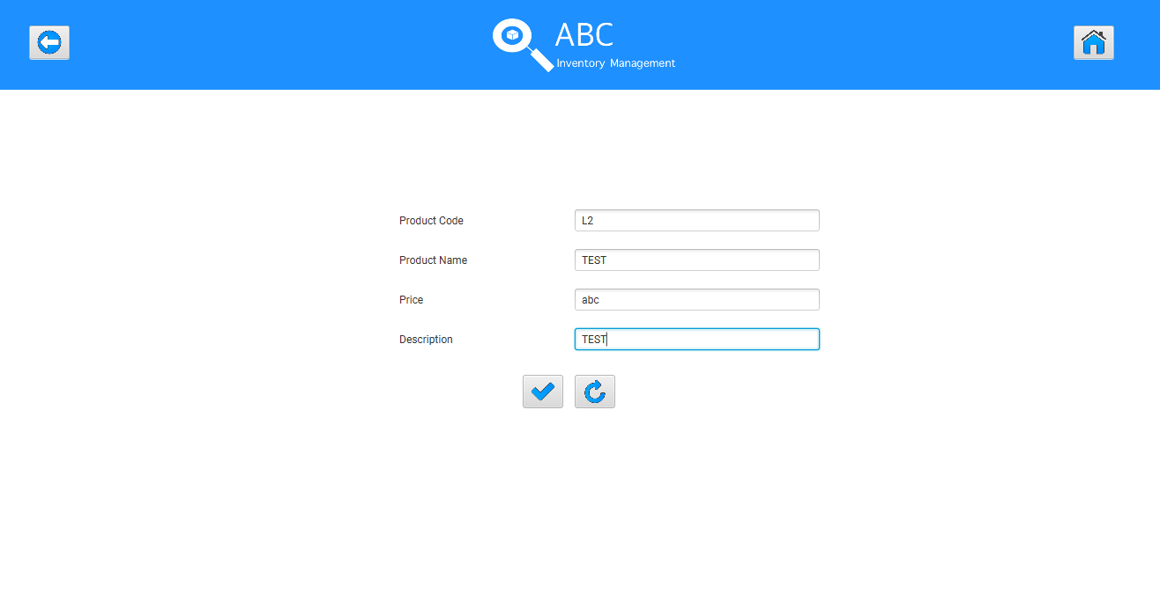

**Step 3**

System displays an appropriate message.

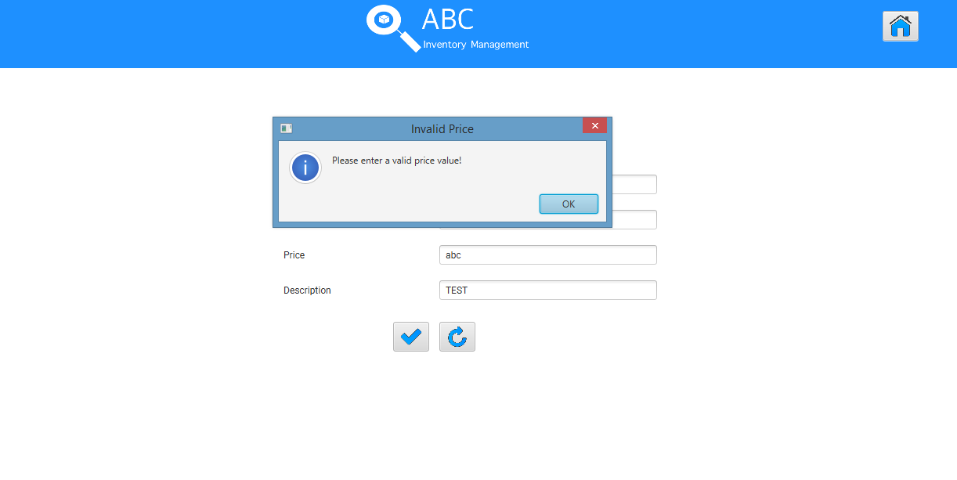

**Step 4**

System clears the price field and highlights it with red.

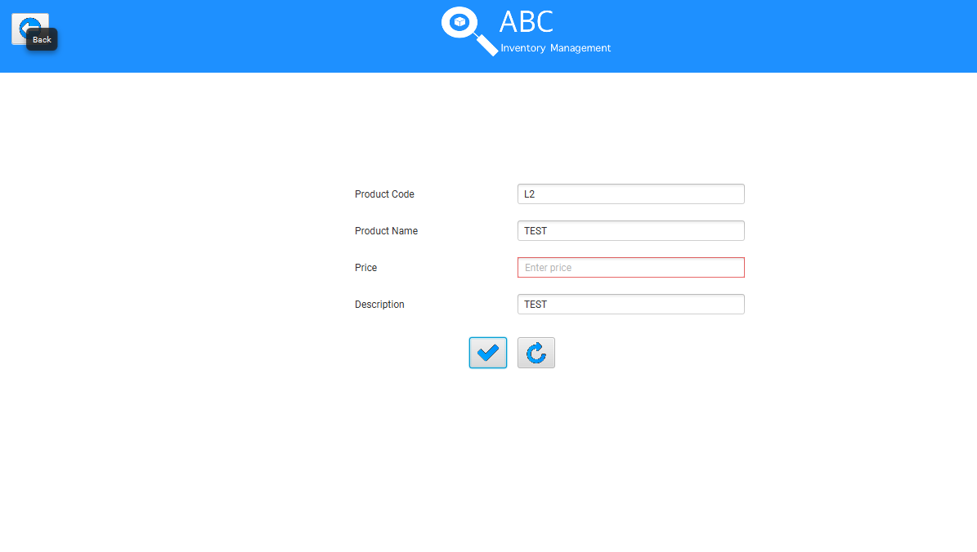

## Data Set 2

|  |  |
| --- | --- |
| **Data Set 2** | |
| **Fields** | **Values** |
| **Product Code** | L2 |
| **Product Name** | TEST |
| **Price** | -99.00 |
| **Description** | TEST |

### Result Screenshots:

**Step 1**

After clicking on ‘Add Product’ Icon at ‘Manage Product’ system prompts user to enter new product details.



**Step 2**

Enter an invalid price (A negative value).

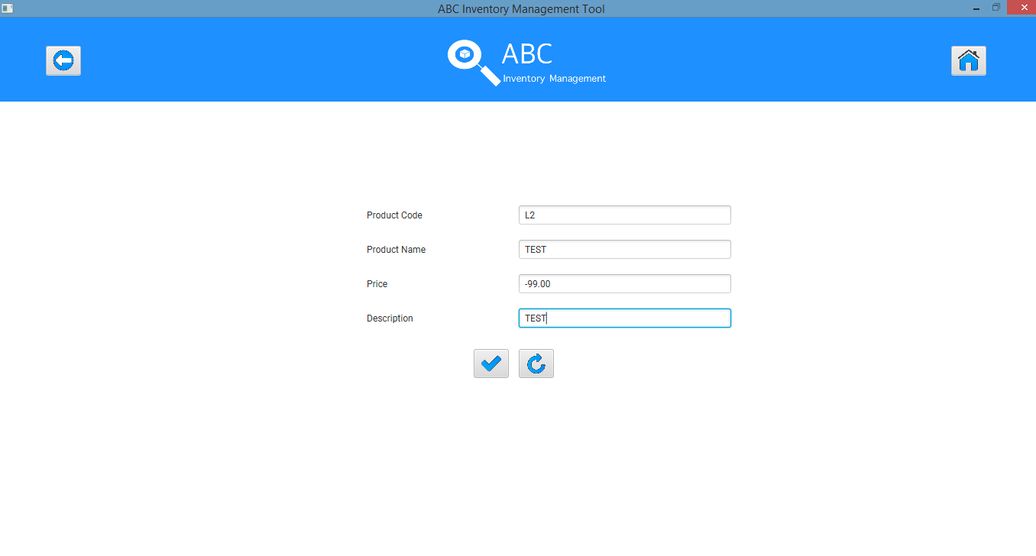

**Step 3**

System displays an appropriate message.

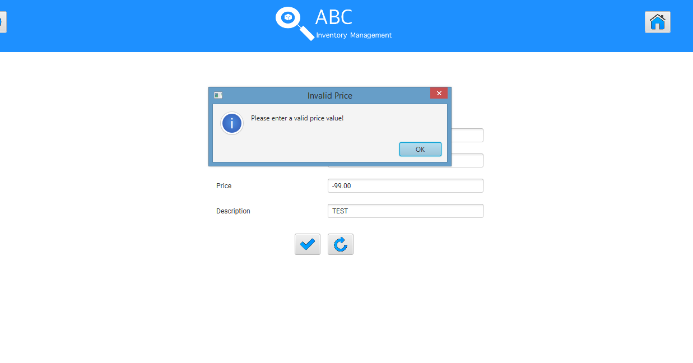

**Step 4**

System clears the price field and highlights it with red.

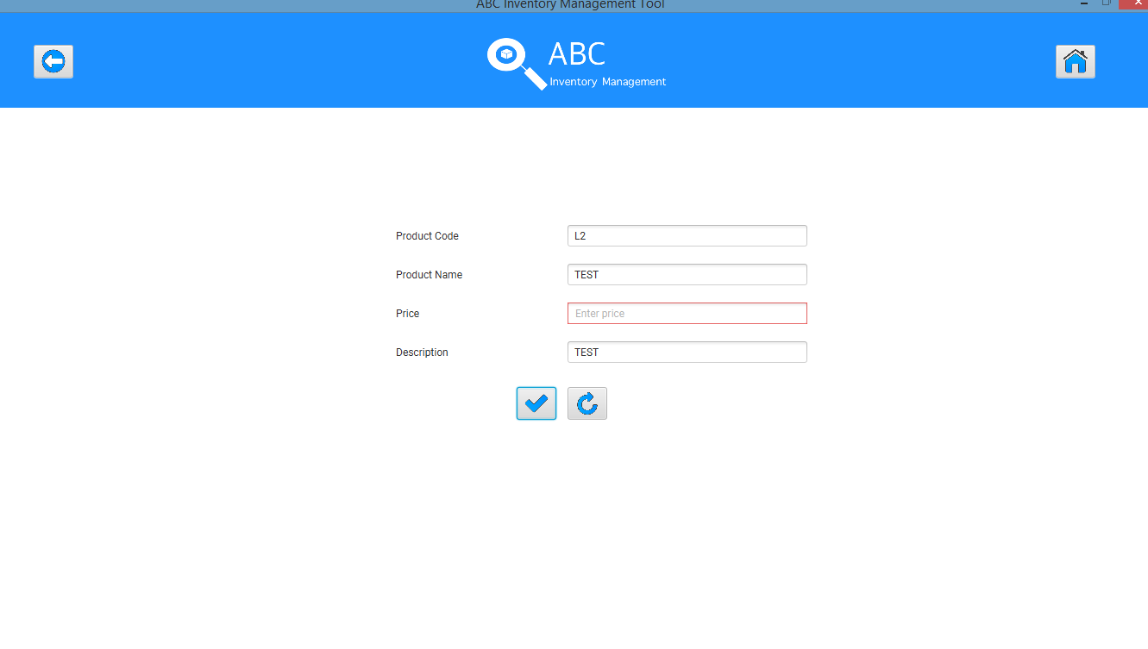

# APT006- Enter all details then click on the ‘Clear’ Icon

|  |  |  |  |  |  |
| --- | --- | --- | --- | --- | --- |
| **Test Name** | | Test enter all details then click on the ‘Clear’ Icon. (Test APT006) | | | |
| **Use Case Tested** | | Manage Product | | | |
| **Test Description** | | This test tests how the system reacts when the user clicks on the ‘Clear’ icon. | | | |
| **Pre-Conditions** | | Users need be logged in as a Warehouse Staff (Warehouse Staff Access) in the Manage Product page.  Meta data to store Product details in the database must exist. | | | |
| **Post-Conditions** | | All fields are cleared. | | | |
| **Result (Pass/Fail/Warning/ Incomplete)** | | Pass | | | |
|  | **Test Step** | | **Expected Test Results** | **P** | **F** |
| 1. | Click on ‘Add Product’ icon at ‘Manage Product’. | | System prompts user to enter new product details. | P |  |
| 2. | Enter all required data accurately. | | System waits for user to click on the ‘Add Product (Tick)’ icon. | P |  |
| 3. | Click on ‘Clear’ icon. | | The system clears all fields. | P |  |

## Data Set 1

|  |  |
| --- | --- |
| **Data Set 1** | |
| **Fields** | **Values** |
| **Product Code** | L2 |
| **Product Name** | TEST |
| **Price** | 39.00 |
| **Description** | TEST |

### Result Screenshots:

**Step 1**

After clicking on ‘Add Product’ Icon at ‘Manage Product’ system prompts user to enter new product details.



**Step 2**

Enter all data accurately.

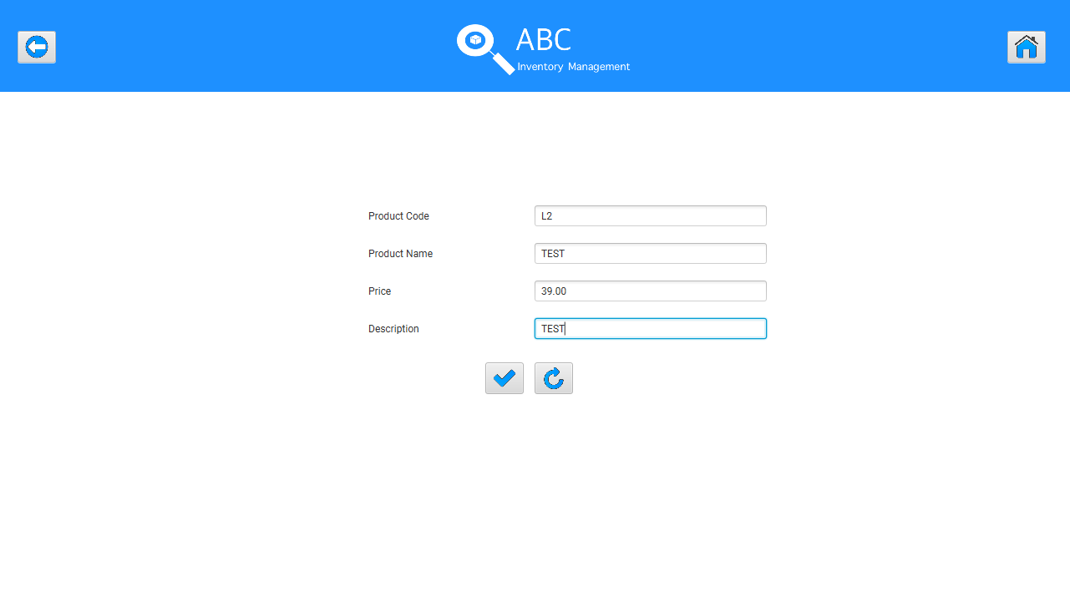

**Step 3**

After user clicks on the ‘Clear’ icon.

